

**FKMP**

**Semester II Session 2022/2023**

**Robotics**

**BDC40603**

**Lecturer: Dr. Cheng Yee Low**

**Report Title: Control of Niryo One**

**Date: 28 June 2023**

**Table of Contents**

1. Introduction 3

2. Theory 4

3. Laboratory Results 5

3.1 Setup 5

3.2 Execution 7

3.3 Programming 8

7. References 9

# 1. Introduction

The scenario, where our robot is needed is a factory that produces printed circuit boards. In the production hall the factory has two machines. They are part of one production line. The first machine is thrilling the holes into the board, the second machine is printing the circuits onto the board. The machines are not physically connected. Workpieces that leave the first machine need to enter the second machine. Furthermore, there is air cleaning device in between the machine. This device is needed to make air conditions suitable to prevent breathing trouble of workers. The issue is that the device is an obstacle and the transport of boards between the two machines is hard. A new robot shall help in this situation. This robot needs to be able lift a board from the first to the second machine, over the obstacle.

This project is designing a robot that moves … . The issue is that in its task environments there is an obstacle to avoid. This project shows the theory and implementation of this case.

# 2. Theory

# 3. Laboratory Results

This chapter shows the physical execution of the project. An explanation of the setup is followed by a execution description and an insight into the code.

## 3.1 Setup

This chapter will discuss how to implement a robot into the environment described in the introduction. To show a solution how to move the boards around an obstacle with a robot, the following situation model got created in the laboratory.

A robot picks up the circuit boards, which are simulated by UTHM student cards, as they have a similar thickness. The robot moves the cards over the cardboard box, which reflects the air cleaning device. The cards get laid down on the right side of the box. A detail explanation of the set up follows later in this chapter.

The project is conducted with the Niryo One. It is a six-axis robot. This gives the robot enough degrees of freedom to move around the obstacle.

Picking up the cards is an issue. The standard claw is not capable of clamping a card. By not being accurate enough, the gripper could easily miss the card and do the lifting without attached object. It is also wished to just take the top card. The gripper has the risk of taking several cards with one take. Therefore, it was decided to use a vacuum gripper.

The vacuum gripper and its working principal is shown in detail in the following figure.

Figure 3.1: Overview Lab

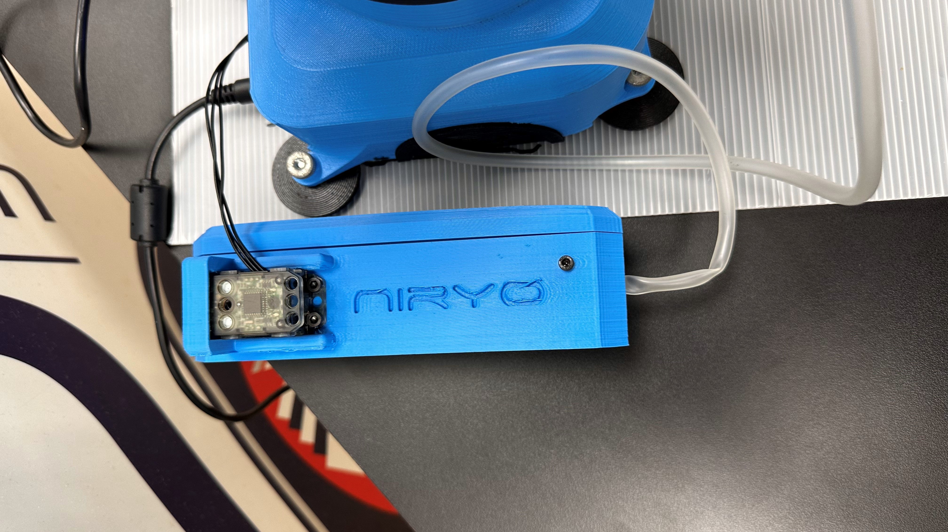 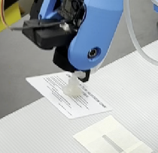

Figure 3.2: Vacuum gripper

The vacuum gripper consists of two parts. The pump, that is show on the left side of the figure. It generates the low pressure. The low pressure is then transferred to the gripper, shown on the right side. To attach an object, the robot arm needs to position the vacuum cup abut to the object before the vacuum gets generated.

The exact model assembly is shown in the figure below:

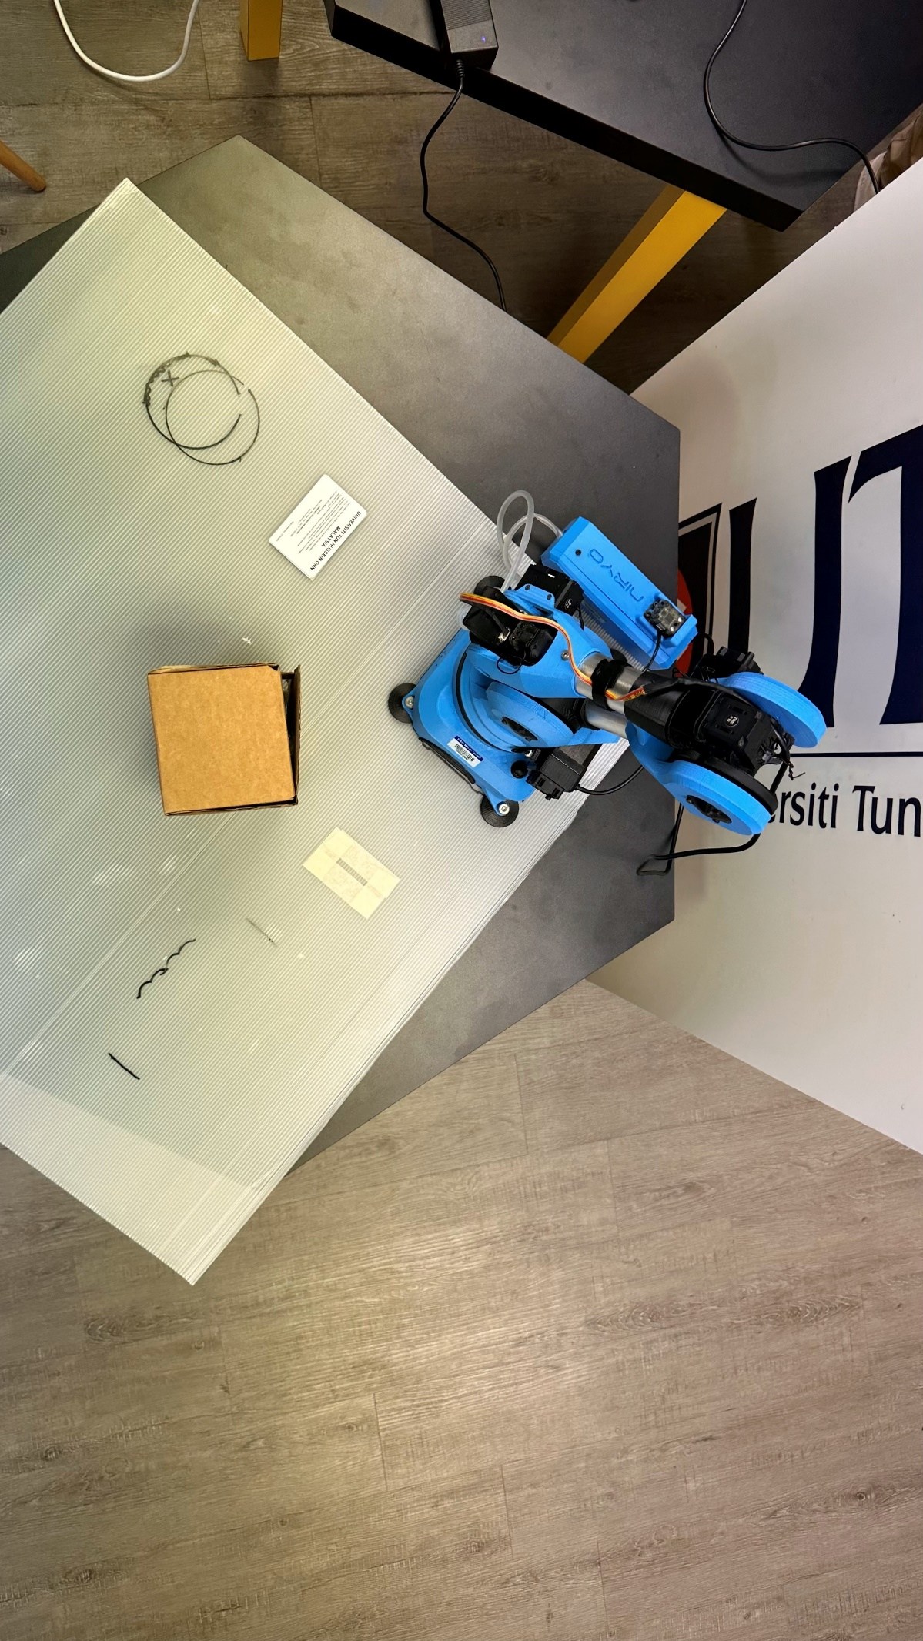

1

3

2

Figure 3.3: Topview assembly

Marked with number one is the area, where the first machine puts the finished cards. It is the pick-up location for the robot. A sample of cards already are available for pick-up. The drop-off area for the robot is marked by the white rectangle numbered with the two. It is the start position for the second machine. Marked by number three is the obstacle box, that represents the air cleaner.

## 3.2 Execution

|  |  |
| --- | --- |
|  |  |
| Pick-up | Before obstacle |
|  |  |
| After obstacle | Drop-off |

Figure 3.4: Execution sequence

After starting from its origin position the robot position itself into the pick-up location like shown in the above figure. The pump of the vacuum gripper than gets activated. The card is now attached to the vacuum cup. The robot starts the lifting. It takes a path around the obstacle. Figure 3.4 shows a position before and after the obstacle. This shows that after the card got gripped the robot needs to lift it over the obstacle. In the end the object gets dropped off int the wished destination.

For picking up the next card, the robot has to take the same route to return to the first machine.

## 3.3 Programming

The programming is done with Niryo One Studio desktop application. This is a block programmable tool. The user has to create a set of coordinates. Each coordinate is a block. The coordinate blocks get attached in order of the path. The orange blocks activate and deactivate the vacuum pump. All steps are within a repeat loop. The robot redoes the steps as often as wished. As soon as the loop is ended the robot is send to the start position.

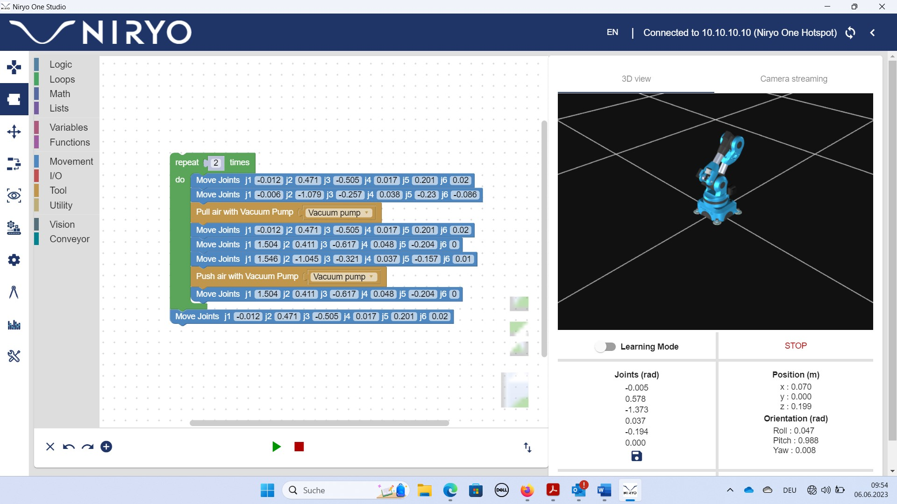

Figure 3.5: Niryo One Studio

The coordinates are determined by pushing the robot arm into the destined positions and safe the coordinates. To safe a position, one has to press the button on the side of the robot. The software tool than automatically creates a block. This block can be used like shown above. It can be duplicated to be used several times.

It is possible to limit the moving speed of the joints. The achieve the fastest possible production, the arms are running at a speed of 100%.

# 7. References

|  |  |
| --- | --- |
| [x] | European Environment Agency, “Transport”, *eea.europa.eu*, para. 1, Mar. 15, 2023. [Online]. Available: <https://www.eea.europa.eu/themes/transport/intro> [Accessed: May 25, 2023] |
| [1] | Niryo, “Niryo One documentation”, *nyrio.com*, Feb. 13, 2018. Available: <https://niryo.com/docs/niryo-one/> [Accessed: Jun. 07, 2023] |
| [2] |  |
| [3] |  |
| [4] |  |
| [5] |  |